
AMERICAN O & P LAB LLC. UPPER EXTREMETY
Custom Fabrication Work Order Form
15681 N Cave Creek Rd Suite # 6 Date ________________
Phoenix AZ 85032
Phone (480) 209 1543 Cell (480) 458 8181 PCC # _______________
Clinic Information

Clinic Name _______________________________Practitioner Name ________________________
Address ___________________________________City ____________________Zip ______________
Phone# :_____________________ Fax # :____________________Email _______________________
Patient Name _____________________ ☐ M ☐ F Amputation Side ☐ Left ☐ Right
Patient Information
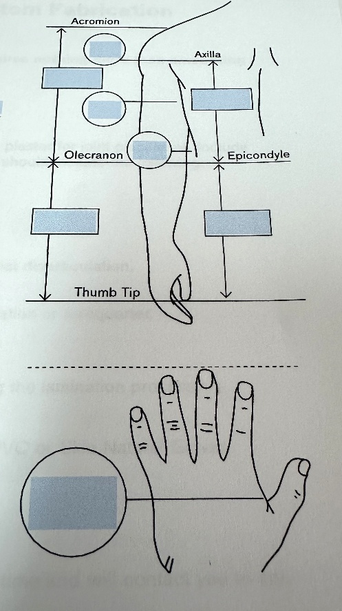
Job Type Duplication
☐ Test Socket ☐ Socket Only
Material __________________ ☐ Entire Prosthesis
☐ Rough Trial Set Up ☐ Transfer All Existing Components
Material _________________ ☐ Use new components ☐ Definitive Socket ☐ Maintain existing Alignment
☐ Use new alignment and measurements
Socket Lamination
☐ Rigid ☐ 99B13 Standar Pull Tube
☐ Heavy Duty Construction ☐ 12V10 Tuve valve
☐ Flexible Proximal Brim ☐ Other _________________ ☐ Color_____________________
Inner Socket Valve Options Input Devices & Quantity
☐ Lamination ☐ 21 Y 14push valve ☐ 13E200 Electrode QTY _____
☐ Proflex ☐ 21 Y 21 Click Valve ☐ 13E 202 Suction Electrodes Qty ________________ ____
☐ With Silicone ☐ Other ___________ ☐ Switch/ linear transducer Type ____________________
☐ With out Silicone to control ________________________________________
☐ Thermolyn supra flex ☐ Myo plus pattern recognition
☐ Color ____________ ☐ Other ___________________________________________

